**MDF Rose Engine Lathe 2.0**

**with Stepper Motor Drive**

**Instructions for**

**Building ELFOS**

**Part 2 – MDF Case**

**Version 4.1**

**17 March 2024**

Permission is not granted to manufacture these for sale.

Table of Contents

Section 1 – Controls Box Enclosure 5

Before Assembly 5

Assembly 9

Plates for Connectors 9

Section 2 – Assembly of the Control Box Electronics 13

Mounting Electronics to the MDF Base 13

Notes Regarding the V3 Board 14

Notes Regarding the Overhead Drives Control 14

Document Version History 15

Some have chosen to put the stepper motor controls in the lathe’s carcass, under the bed of the lathe. However, placing all the pieces together in a separate box gives these benefits:

**MDF Rose Engine Lathe 2.0**

**(B1 and B1A removed)**

1. This controls box is designed be placed under the bed in the MDF Rose Engine Lathe 2.0 (as shown in the picture to the right {the bed cover is removed}).
2. This approach also allows for the controls box to be used with the original MDF Rose Engine Lathe, just placing the box somewhere near the lathe.
3. This also frees up space under the bed for:
   1. Storage of parts or tools, or
   2. Making a gap-bed lathe.
4. The many connections between the various pieces inside the box are already in place and the user does not have to figure out the correct alignment of connectors when building the MDF Rose Engine Lathe.

The details for how we are building the one you can buy are below. These are documented for our use to ensure consistency, and we are publishing them for anyone who wishes to build their own.

The sequence of activities follows the layout of this document. That was done consciously. Changes to the sequence should be considered strongly before making changes.

|  |
| --- |
| Section 1 – Controls Box Enclosure |

## Before Assembly

The following instructions should be followed before assembling the controls box

### Bottom

This is made from ¾” MDF.

**6”**

**16”**

### Top

This is made from ¾” MDF. This layout is for the version 2 or version 3 plate in the book titled, 3D Printed Parts. If you use version 1, modify the layout as necessary.

For the 3D-printed plate’s mounting holes, it is best to drill them based on the plate’s position after cutting the opening. Do be sure it is properly aligned before drilling the holes.

**½” radius**

**(typ)**

**10 3/8”**

**5 ¼”**

**1 ½” dia**

**4”**

**1 1/8”**

**1”**

**1”**

**2”**

**16”**

**3”**

**6”**

### Long Sides (2)

There are two of these, and they are made from ¼” MDF.

**16”**

**6 ½”**

### Short Sides (2)

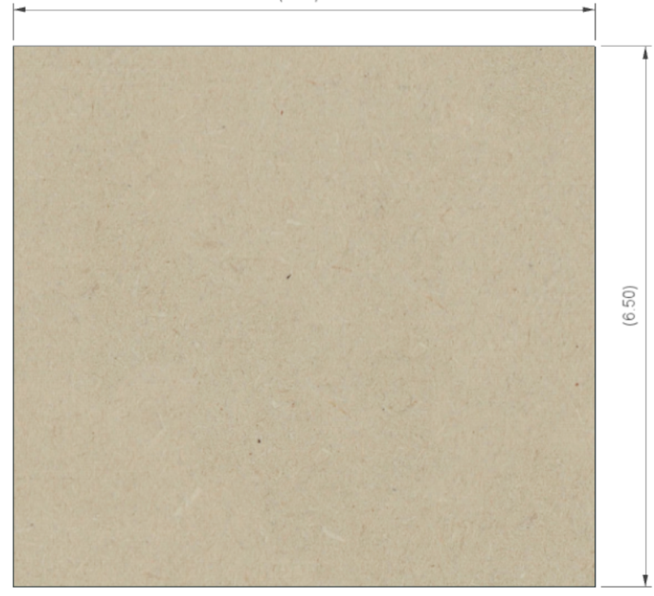

**6 ½”**

**6 ½”**

There are two of these, and they are made from ¼” MDF.

## Assembly

## Plates for Connectors

### A close up of a speaker Description automatically generatedPower Infeed

Use a 1-gang plate with the hole punched out for the cable strain relief. Secure the power cable in place using the 3/8 in. Twin-Screw Cable Clamp Connector. Wait until later to tighten the screws holding the power cable into place.

### Power Switch

Use the 3D-printed plates and install the main power switch in the position indicated.

The positions indicated for the overhead drive are a separate option, and detailed in “Instructions for Building Jigs, Fixtures, & Add-Ons”.

Once the power switch has been installed, this plate can be attached to the MDF top. That is recommended as this allows for the wiring to be tied neatly down. When attaching the plate, try to clock the screws. This will provide a nicer look. (This is a nice web site showing more on that 🡺 <https://blog.lostartpress.com/2019/04/18/the-church-of-the-clocked-screws/>)

**DO NOT POWER IT ON YET.** Unless you have covered the switch’s terminals, they will have power on them and can shock you easily.

|  |  |  |
| --- | --- | --- |
| Limit Switch Jacks Install these jacks in the positions indicated. | HMI Jack Install the HMI jack in the position indicated. | Stepper Motor Jacks Install these jacks in the positions indicated. |

### Graphical user interface, application Description automatically generatedmicroSD Extension

The microSD extension cable

is installed here.

Insert this end first

And before fully seating this end, ensure the image embedded on one side is up. This is not critical but makes it easier to insert the microSD card later as the pins will always be down.

|  |
| --- |
| Section 2 – Assembly of the Control Box Electronics |

## Mounting Electronics to the MDF Base

Mount the electronics to the base piece of the MDF. The PCB is secured to the MDF with the ¼” spacers under the 4 corners to place the board so that there is a ¼” gap below.

**LRS-100-24**

**DM542T – B/M3 Axis**

Spacing between DM542Ts is 1” or so. This space between them allows for distribution of heat.

**DM542T – Spindle**

**PCB**

(sitting atop spacers)

**DM542T – X Axis**

**DM542T – Z Axis**

**Terminal Block**

## Notes Regarding the V3 Board

* When using this board, you can have up to 5 controllers (DM542Ts) connected to 5 stepper motors. To accommodate the 5th controller, space them out appropriately, but be sure to keep spacing between them to allow for heat to evacuate.

## Notes Regarding the Overhead Drives Control

This option requires adding quite a bit more electronics and wiring. Thusly,

* Consider adding a piece of MDF mounted perpendicularly to the bottom board. This will provide a surface for mounting the PCB, the Arduino.
* You should also add a 2nd terminal block for the 120 VAC power distribution.

**Terminal Block**

**120 VAC Power**

**4 ¾” x 4 ¾” MDF Block**

**Overhead Drives Control circuitry on opposite side of MDF block**

**Terminal Block**

**24 VDC Power**

**5th Controller**

# Document Version History

|  |  |  |
| --- | --- | --- |
| Ver | Date | Comment |
| 4.1 | 17 Mar 24 | * Update for ELFOS. Removed instructions for 4-axis PCBs. |
| 4.0 | 08 Jun 22 | * This update accommodates the use of 3D-printed face plate. |
| 3.0 | 19 Aug 21 | * Original document split into 3 parts to allow for different case configurations to be handled easily. |
| 2.1 | 14 Aug 21 | * Changed pins used for limit switches * Added information regarding different Teensy and Nextion displays. |
| 2.0 | 13 Jun 21 | * This document incorporates changes to the way cables are attached to the PCB. It now shows how to use connectors in lieu of soldering the wires directly to the board. |
| 1.4 | 10 Mar 21 | * Reorganized a few steps to follow better flow of work. * Added notes on using GX-12/4 connector for Nextion display. * Updated instructions for loading software to reference web site. * Also added a few minor other tweaks. |
| 1.3 | 01 Jan 21 | * Added item numbers for optional build using a Pololu Tic (this is a separate document). * Renamed Document |
| 1.2 | 15 Dec 20 | * Added parts to the bill of materials * Added details on the installation of the 3.5mm phono jacks. |
| 1.1 | 10 Dec 20 | * Added details for optional configurations. * Added information for attaching the stepper motor to the headstock |
| 1.0.2 | 07 Dec 20 | * Updated p/n for item #204; also updated p/n & qty for item #102. * Added note on soldering on 3.5mm jacks first. |
| 1.0.1 | 05 Dec 20 | * Updated commentary about stepper motor needed. * Added information about stepper motor mount, pulleys, and belt. * Updated drawing dimensions. |
| 1.0 | 01 Dec 20 | Initial document |

To the extent that material may appear to be infringed, we assert that such alleged infringement is permissible under fair use principles in U.S. copyright laws. If you believe material has been used in an unauthorized manner, please contact me at [ColvinTools@Gmail.com](mailto:ColvinTools@Gmail.com).

The layout of the Printed Circuit Board (PCB) is copyright Ed French and is used with his permission.

Permission is not granted to manufacture these for sale.